Grace Lutheran Church

*Lutheran Church – Missouri Synod*

**3000 West Golf Course Road**

**Midland, Texas 79701-2998**

**Church (432) 697-3221**

**ECP Office (432) 694-3063**

[www.gracelutheranmidlandtx.org](http://www.gracelutheranmidlandtx.org)

[office@gracelutheranmidlandtx.org](mailto:office@gracelutheranmidlandtx.org)

**WELCOME TO GRACE:** We rejoice over your presence this day as we gather in the Name and in the worship of our Lord. If you are a GUEST with us today, we hope you feel welcome in our church family and invite you to worship with us again. If you are interested in membership at Grace or want to know more about our church and our faith, please indicate your interest on the ATTENDANCE FORM in the pew.

**Grace’s Mission**

**T** Sharing God’s Grace

**T** Living His Word

**T** Making Disciples

**Grace Lutheran Church** is one of more than six thousand congregations of the Lutheran Church-Missouri Synod.

**We Believe** the Bible is the inspired Word of God and the sole source for all Christian teaching and practice. *II Timothy 3:16*

**We Believe** “God so loved the world that He gave His only begotten Son that whosever believes in Him should not perish but have everlasting life.” *John 3:16*

**We Believe** “by grace you have been saved through faith and that not of yourselves; it is the gift of God, not of works, lest anyone should boast.” *Ephesians 2:8-9*

**We Believe** our relationship with everyone is based upon Jesus’ words: “Love one another as I have loved you.” *John 15:12*

**Child Care** We care about your children. We encourage parents with small children to help them participate in our worship. We ask you to have your children go to the restroom and get a drink before the service, and refrain from leaving during worship, unless there is an emergency. We have available a cry room equipped with sound located at the back of the sanctuary. Children’s bulletins with activities are available.

**Hearing Impaired** For those who need assistance, please ask an usher for a wireless hearing aid. They are easy to use.

# **Please see Grace in Action for the week’s calendar and other**

# **Important information regarding the ministry of our congregation!**

**WORSHIP FOLDER**

**Seventh Sunday After The Epiphany**

**February 23, 2025**

“Is It Possible?”

**As We Gather**

Today’s Old Testament Reading is the account of Joseph forgiving his brothers, who had sold him into slavery years earlier. Is it possible for us to forgive as he did? Joseph learned to trust in God and how He would arrange things. God has arranged everything for us too! The resurrection of Jesus is beyond our understanding but not beyond our comprehension. So Paul tries to explain about heavenly beings. We don’t know much about them, but we can forgive because our Lord went a lot farther than we are called to follow, into death, for God to forgive us. Today Word and Sacrament strengthen us to follow His example in daily living.

[If your health limits you, please don’t feel required to stand during the worship service.]



1

2

*In the Name of the*

*Father, Son, and*

*Holy Spirit*



**Pre-Service Music**

**Welcome**

**T Service of Preparation T**

**Entrance Hymn** *(please stand for last stanza)* LSB 725

*“Children of the Heavenly Father”*

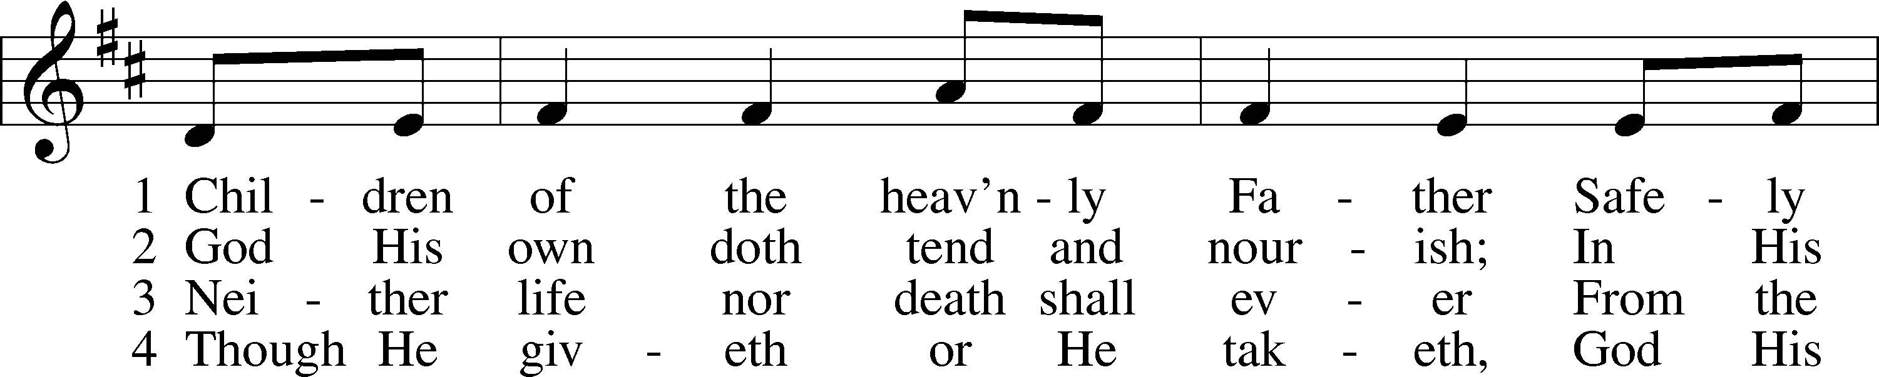

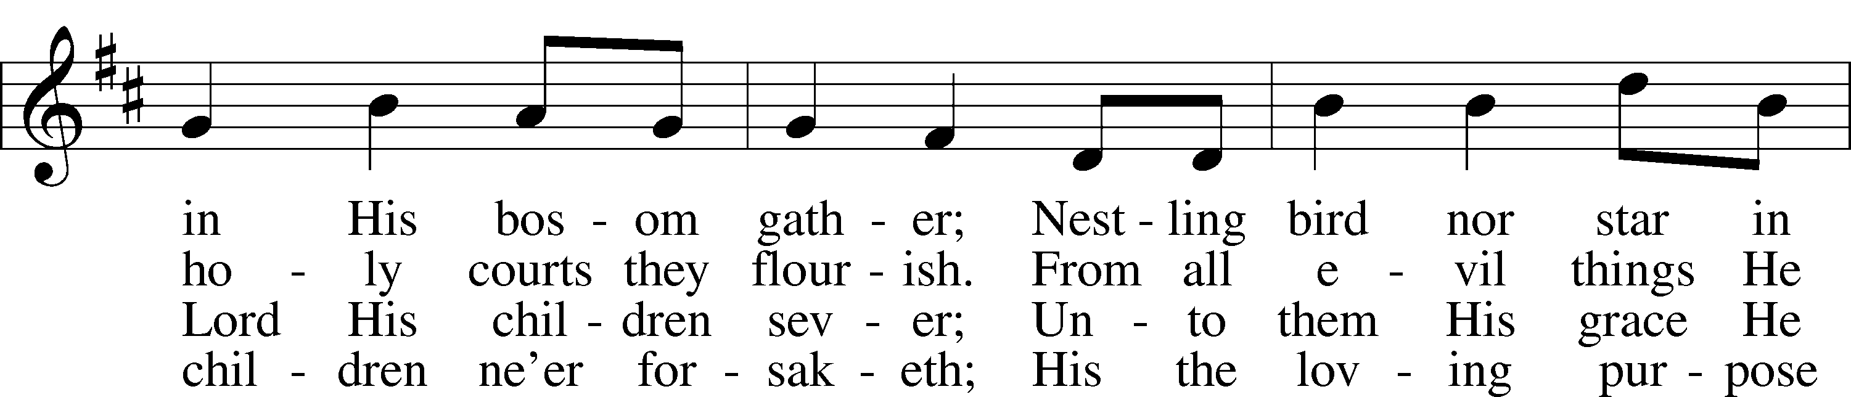

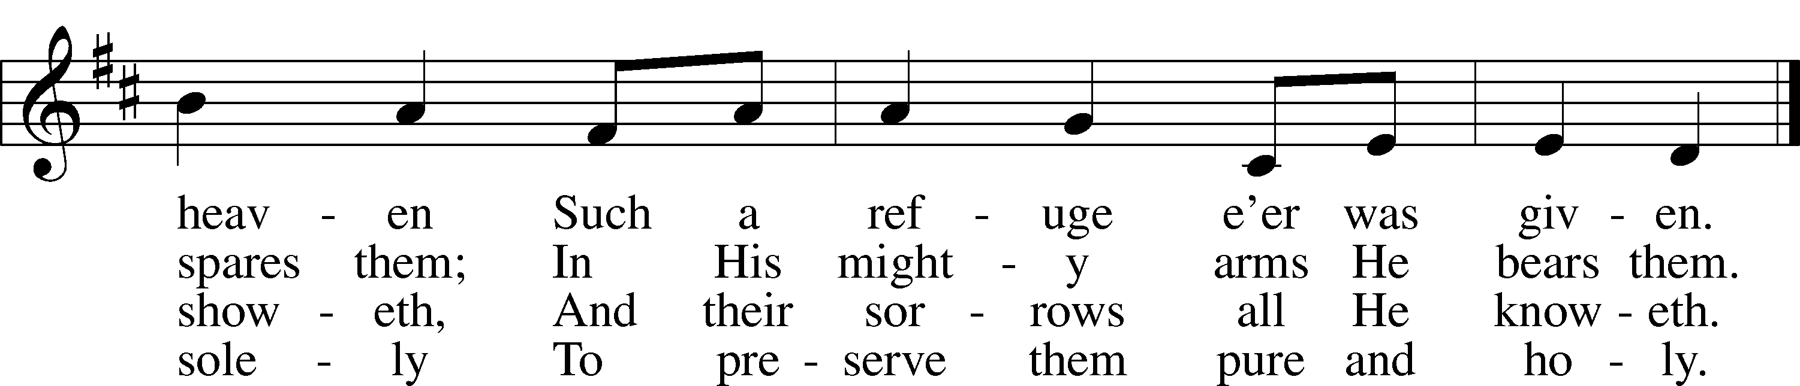

Text: Public domain  
Tune: Public domain

**Invocation**

P In the name of the Father and of the ✠ Son and of the Holy Spirit.

**C Amen.**

**Opening Sentences** *1 Corinthians 15:21–22, 42*

P As by a man came death,

**C by a man has come also the resurrection of the dead.**

P As in Adam all die,

**C so also in Christ shall all be made alive.**

P What is sown is perishable;

**C what is raised is imperishable.**

**Confession and Absolution** *Luke 6:27, 32, 37*

P Confident of our Lord’s victory over death, leading all who follow Him by

faith, let us confess our sins.

“Love your enemies, do good to those who hate you.” We confess our failure

to love our enemies, O Lord.

**C We have responded to them as they have dealt with us. We have not done**

**to them as we wish they would have done to us. Forgive us, Father.**

P “If you love those who love you, what benefit is that to you?” We confess our

giving preference to people who are like us.

**C We have loved those near and dear to us and have dealt with others**

**without love and mercy. Forgive us, Lord Jesus.**

P “Judge not, and you will not be judged.” We confess our judgment of people

we think are not up to the standards we think we can meet.

**C We have failed to pass on the forgiveness we have received from You, O**

**Holy Spirit. Forgive us, Lord our God.**

P “Forgive, and you will be forgiven.” Your sins have been forgiven by the

death and resurrection of our Lord Jesus Christ! As a called and ordained

servant of His, I therefore forgive you in the name of the Father and of the X

Son and of the Holy Spirit.

**C Amen.**



**T Service of The Word T**

**Hymn** LSB 742

*“For Me to Live Is Jesus”*

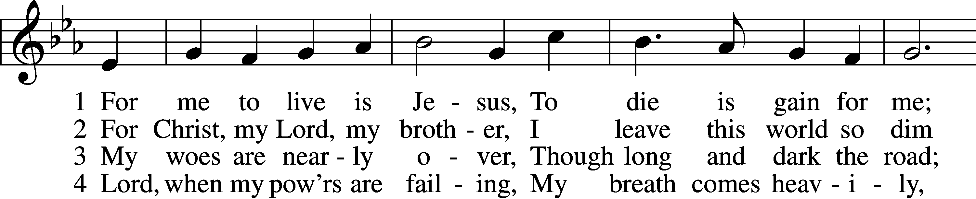

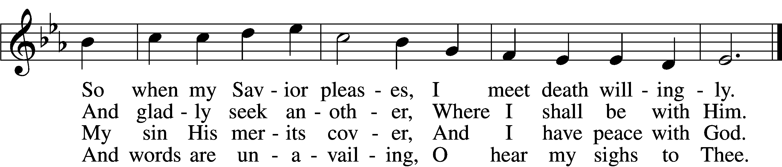

**5 In my last hour, O grant me  
 A slumber soft and still,  
No doubts to vex or haunt me,  
 Safe anchored in Thy will;**

**6 And so to Thee still cleaving  
 When death shall come to me,  
I fall asleep believing  
 And wake in heav’n with Thee!**

Text and tune: Public domain

**Salutation and Prayer of the Day**

P The Lord be with you.

**C And also with you.**

P Let us pray. Lord God, our Creator, Redeemer, and Sanctifier, we pray Your

protection and guidance.

**C Be a ready source of strength so that the world around us will not deceive**

**us and lead us from Your guidance and forgiveness;**

P through Jesus Christ, Your Son, our Lord, who lives and reigns with You and

the Holy Spirit, one God, now and forever.

**C** **Amen.**

*(please be seated)*

**Old Testament Reading** Genesis 45:3-15

*(Joseph explains to his brothers that God is really in control of all things, including their selling him into slavery.)*

L The Old Testament Reading for the Seventh Sunday after Epiphany is from Genesis, chapter 45:

L 3 Joseph said to his brothers, “I am Joseph! Is my father still alive?” But his

brothers could not answer him, for they were dismayed at his presence. 4So Joseph said to his brothers, “Come near to me, please.” And they came near. And he said, “I am your brother, Joseph, whom you sold into Egypt. 5And now do not be distressed or angry with yourselves because you sold me here, for God sent me before you to preserve life. 6For the famine has been in the land these two years, and there are yet five years in which there will be neither plowing nor harvest. 7And God sent me before you to preserve for you a remnant on earth, and to keep alive for you many survivors. 8So it was not you who sent me here, but God. He has made me a father to Pharaoh, and lord of all his house and ruler over all the land of Egypt. 9Hurry and go up to my father and say to him, ‘Thus says your son Joseph, God has made me lord of all Egypt. Come down to me; do not tarry. 10You shall dwell in the land of Goshen, and you shall be near me, you and your children and your children’s children, and your flocks, your herds, and all that you have. 11There I will provide for you, for there are yet five years of famine to come, so that you and your household, and all that you have, do not come to poverty.’ 12And now

your eyes see, and the eyes of my brother Benjamin see, that it is my mouth that

speaks to you. 13You must tell my father of all my honor in Egypt, and of all that you have seen. Hurry and bring my father down here.” 14Then he fell upon his brother Benjamin’s neck and wept, and Benjamin wept upon his neck.

15And he kissed all his brothers and wept upon them. After that his brothers talked with him.

L This is the Word of the Lord.

**C Thanks be to God.**

**Gradual** Psalm 117:1-2a; 96:8

L Praise the Lord, all nations!

**C Extol Him, all peoples!**

L For great is His steadfast love toward us,

**C and the faithfulness of the Lord endures forever.**

L Ascribe to the Lord the glory due His name;

**C bring an offering, and come into His courts!**

**Epistle** 1 Corinthians 15:21-26, 30-42

*(What is sown is perishable, what is raised is imperishable.)*

L The Epistle reading for today is from the first letter to the Corinthians, chapter fifteen:

21For as by a man came death, by a man has come also the resurrection of the dead. 22For as in Adam all die, so also in Christ shall all be made alive. 23But each in his own order: Christ the firstfruits, then at his coming those who belong to Christ. 24Then comes the end, when he delivers the kingdom to God the Father after destroying every rule and every authority and power. 25For he must reign until he has put all his enemies under his feet. 26The last enemy to be destroyed is death. . . .

30Why am I in danger every hour? 31I protest, brothers, by my pride in you, which I have in Christ Jesus our Lord, I die every day! 32What do I gain if, humanly speaking, I fought with beasts at Ephesus? If the dead are not raised, “Let us eat and drink, for tomorrow we die.” 33Do not be deceived: “Bad company ruins good morals.” 34Wake up from your drunken stupor, as is right, and do not go on sinning. For some have no knowledge of God. I say this to your shame.

35But someone will ask, “How are the dead raised? With what kind of body do they come?” 36You foolish person! What you sow does not come to life unless it dies. 37And what you sow is not the body that is to be, but a bare kernel, perhaps of wheat or of some other grain. 38But God gives it a body as he has chosen, and to each kind of seed its own body. 39For not all flesh is the same, but there is one kind for humans, another for animals, another for birds, and another for fish. 40There are heavenly bodies and earthly bodies, but the glory of the heavenly is of one kind, and the glory of the earthly is of another. 41There is one glory of the sun, and another glory of the moon, and another glory of the stars; for star differs from star in glory.

42So is it with the resurrection of the dead. What is sown is perishable; what is raised is imperishable.

L This is the Word of the Lord.

**C Thanks be to God.**

*(please stand)*

*(Tradition dictates that our eyes follow the cross. Please remain standing until the cross has been returned to its original position. The Gospel is read from the center of the church to symbolize the Gospel in our midst.)*

**Verse and Alleluia**

P Alleluia. Be merciful, even as your Father is merciful. Alleluia. *Luke 6:36.*

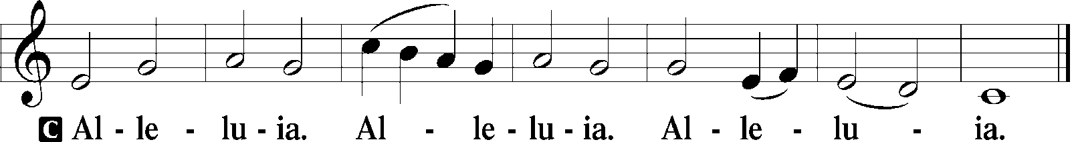

**The Holy Gospel** Luke 6:27-38

*(Jesus preaches about loving our enemies, beggars we meet, and others.)*

P The Holy Gospel according to St. Luke, the 6th chapter.

**C Glory be to you, O Lord.**

27[Jesus said:] “But I say to you who hear, Love your enemies, do good to those who hate you, 28bless those who curse you, pray for those who abuse you. 29To one who strikes you on the cheek, offer the other also, and from one who takes away your cloak do not withhold your tunic either. 30Give to everyone who begs from you, and from one who takes away your goods do not demand them back. 31And as you wish that others would do to you, do so to them. 32“If you love those who love you, what benefit is that to you? For even sinners love those who love them. 33And if you do good to those who do good to you, what benefit is that to you? For even sinners do the same. 34And if you lend to those from whom you expect to receive, what credit is that to you? Even sinners lend to sinners, to get back the same amount. 35But love your enemies, and do good, and lend, expecting nothing in return, and your reward will be great, and you will be sons of the Most High, for he is kind to the ungrateful and the evil. 36Be merciful, even as your Father is merciful. 37“Judge not, and you will not be judged; condemn not, and you will not be condemned; forgive, and you will be forgiven; 38give, and it will be given to you. Good measure, pressed down, shaken together, running over, will be put into your lap. For with the measure you use it will be measured back to you.”

P This is the Gospel of the Lord.

**C** **Praise to You, O Christ.**

*(please be seated)*

**Children’s Sermon**

**Hymn of the Day** LSB 706

*“Love in Christ Is Strong and Living”*

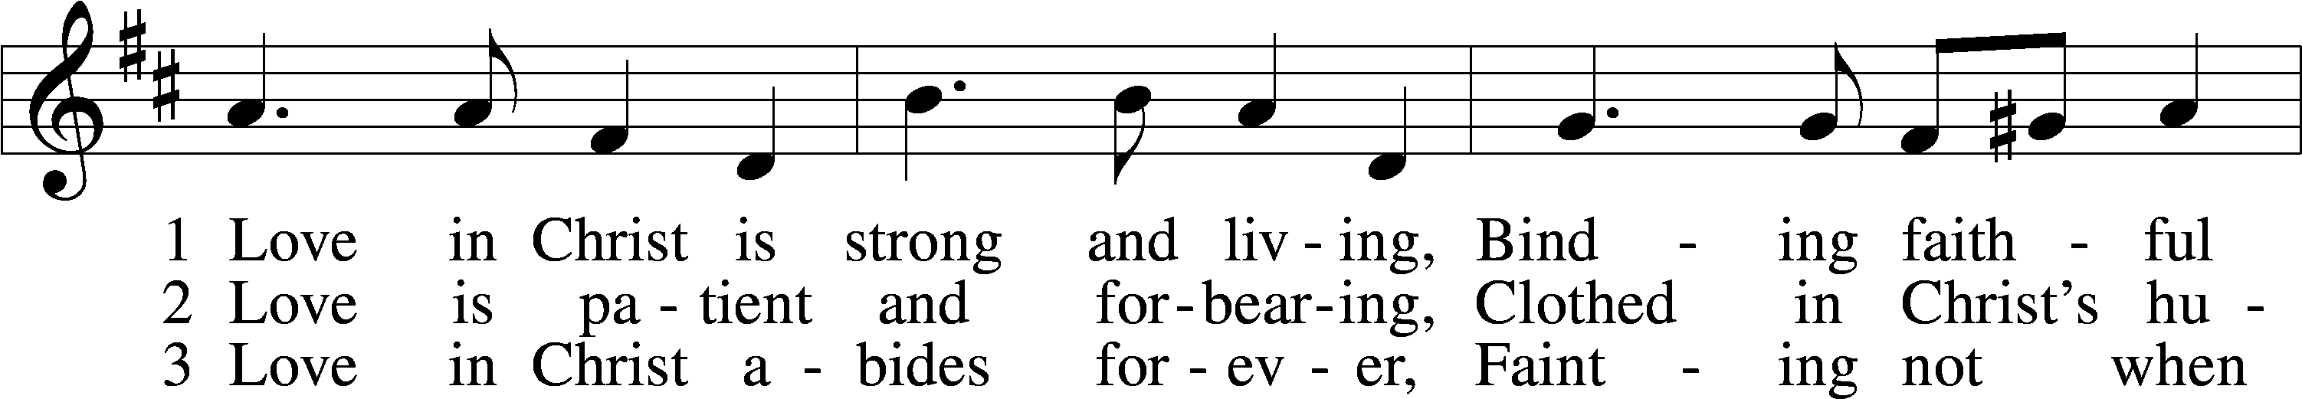

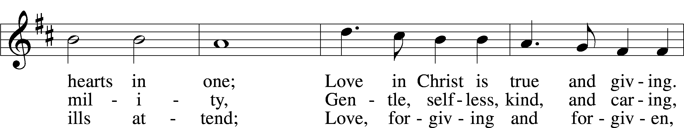

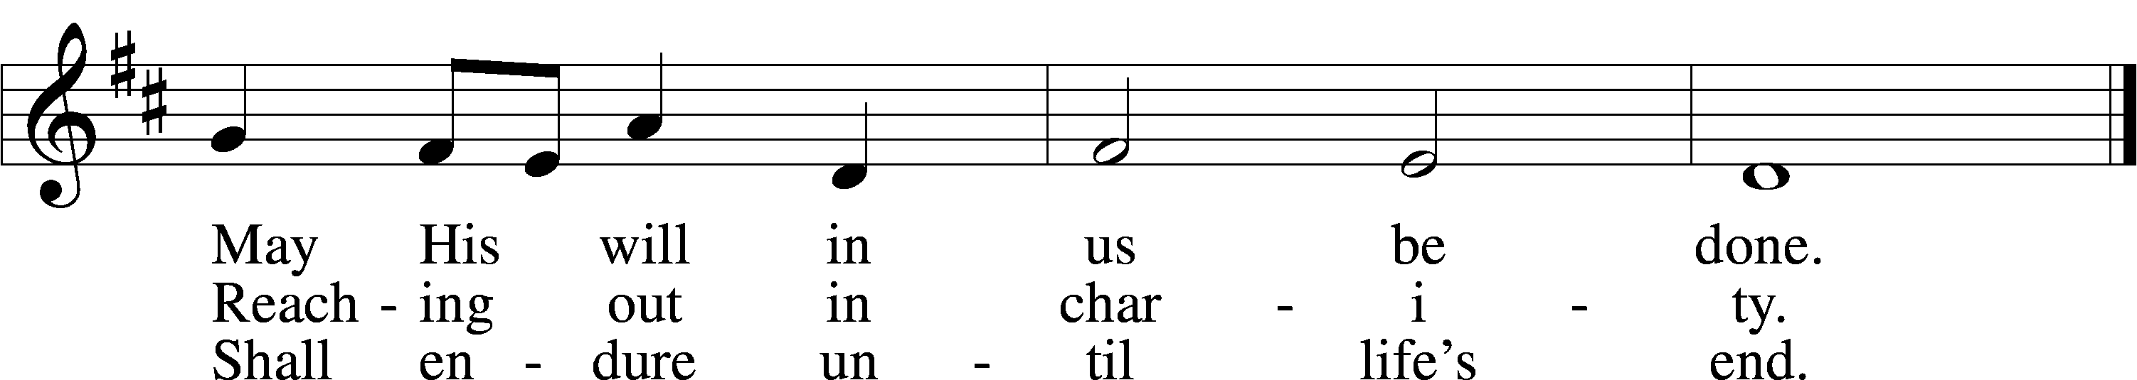

Text and tune: © 1979 Concordia Publishing House. Used by permission: LSB Hymn License no. 110005190

**Sermon Text:** *Luke 6:27-38*

**Sermon Title:** *“Can’t We Just Get Along?”*

*(please stand)*

**Apostles' Creed**

**I believe in God, the Father Almighty, maker of heaven and earth.**

**And in Jesus Christ, His only Son, our Lord,**

**who was conceived by the Holy Spirit,**

**born of the virgin Mary, suffered under Pontius Pilate,**

**was crucified, died and was buried.**

**He descended into hell.**

**The third day He rose again from the dead.**

**He ascended into heaven and sits at the right hand of God**

**the Father Almighty.**

**From thence He will come to judge the living and the dead.**

**I believe in the Holy Spirit, the holy Christian Church,**

**the communion of saints, the forgiveness of sins, the resurrection of the body, and the life** ✠ **everlasting. Amen.**

*(please be seated)*

**We Offer Our First Fruits**

*(Financial support of Grace Lutheran Church is considered a privilege of membership. Although all offerings are welcome, we do not expect them from our visitors.)*

**Voluntary Joyful Chorus**

*“Christ Is Risen, Christ Is Living”*

*(please stand)*

**Prayer of the Church**

Each petition ends with,

P Let us pray to the Lord.

**C Lord, hear our prayer.**

**The Lord’s Prayer**

**Our Father who art in heaven,**

**hallowed be Thy name,**

**Thy kingdom come, Thy will be done**

**on earth as it is in heaven;**

**give us this day our daily bread;**

**and forgive us our trespasses**

**as we forgive those who trespass against us;**

**and lead us not into temptation,**

**but deliver us from evil.**

**For Thine is the kingdom and the power**

**and the glory forever and ever. Amen.**

**Morning Prayer**

**C I thank You, my heavenly Father, through Jesus Christ, Your dear Son, that You have kept me this night from all harm and danger; and I pray that You would keep me this day also from sin and every evil, that all my doings and life may please You. For into Your hands I commend myself, my body and soul, and all things. Let Your holy angel be with me, that the evil foe may have no power over me. Amen.**

**Benediction**

P The blessing of God almighty – the father, the Son, and the Holy Spirit – be

with you, now and forever.

**C Amen.**

*(please be seated)*

**Announcements**

**Hymn to Depart** LSB 730

*“What Is the World to Me”*

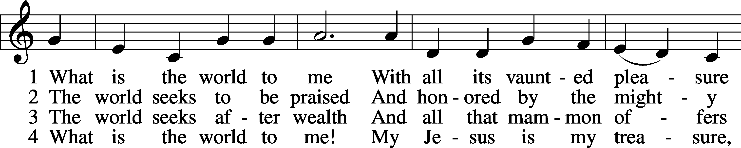

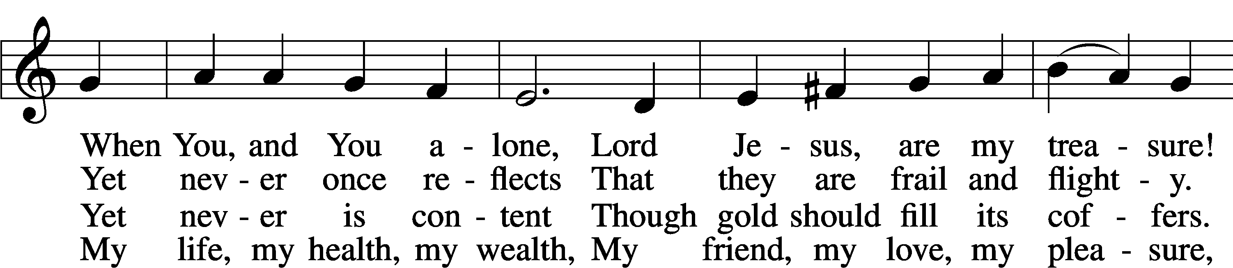

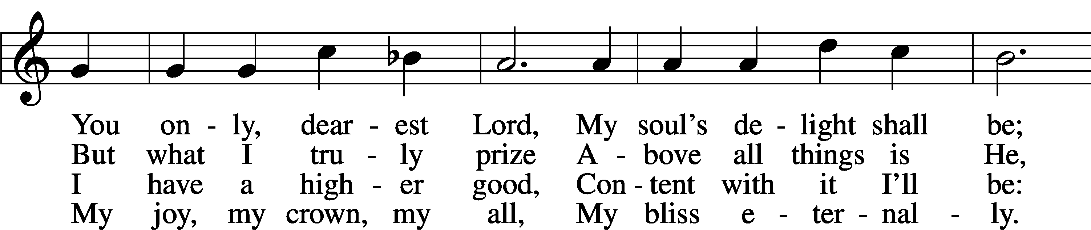

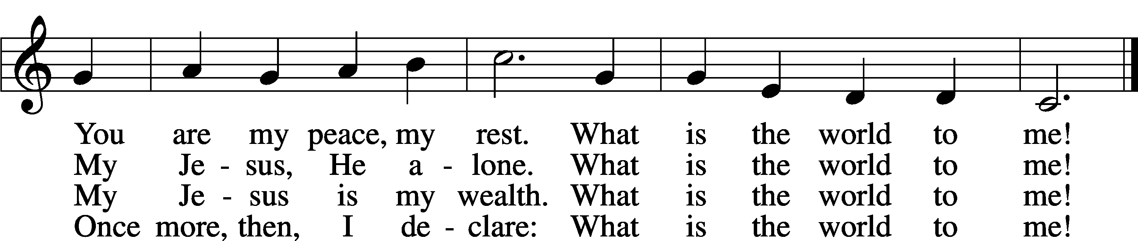

Text and tune: Public domain

**Postlude**

**Acknowledgments**

Divine Service, Setting One from Lutheran Service Book Unless otherwise indicated, all scripture quotations are from *The Holy Bible, English Standard Version*, copyright © 2024 by Crossway Bibles, a division of Good News Publishers. Used by permission. All rights reserved. Created by Lutheran Service Builder © 2024 Concordia Publishing House. Creative Worship for the Lutheran Parish, Series C, Quarter 1. Copyright © 2024 Concordia Publishing House. All rights reserved. Used by permission.

*To God Alone Be the Glory*

**Those Who Serve**

Interim Pastor Rev. Dr. Mike Ramey

Reader Tim Benton

Acolyte Jacob Jones

Organist Virginia DeBerry

Joyful Chorus Director Pat Lufholm

Elders Josh Jones / Brent Keesee

Ushers Todd Byars

Mac Hall

Steve DeShaw

Pete Lufholm

Altar Guild Michelle Wolfmueller

Teller Merle Raven

Nursery Attendant Stephanie & Karsen Mitchell

**Grace Prays**

*We continue to pray for the following:*

* God’s guidance through our time of transition, making our way toward a fresh mission and ministry, led by a new pastor He has in mind for us.
* Wisdom for our nation’s leaders.
* Strength and commitment in tending our baptismal journey.
* For the ministry of our ECP and the families it blesses.
* For our congregation’s leaders, the Spirit would guide their work.
* For our congregation, each member would see that he/she is a vital element for our mission and ministry as a church.

**Ongoing Health Problems**

* Mike Barbian, Charles Colgan, Jerry Damm, Mary Ann Johnston, & Melinda Richmond.

**Ill or Recovering**

* Kathy Cox (Gwen McWhorter’s mom) her L3 is fractured. Saw ortho on 2/3. No lifting, bending, etc. for 3 months. She will have follow-up tests.
* Kristen Riek Haynes (Margaret Cloyd’s granddaughter) has been diagnosed with breast cancer. New drug trial was not approved, so regular chemo has begun.
* Linda (Rhonda Shutts’ sister) her biopsy was positive for cancer.
* Mary Morgan. On 2/4 her doctor found some larger spots in her stomach. She will start on a stronger chemo regimen next week.
* Diane Richey (Carol Massie’s sister) new scan results show cancer in liver & lung have grown. Treatments will continue for now.



The flowers this morning have been provided to the glory of God by

**Mark Roush & Diane Moore**

In memory of Mr. & Mrs. James C. Carter

and

Mr. & Mrs. Roscoe Roush



**Grace Lutheran Church – LCMS**

3000 West Golf Course Road

Midland, Texas 79701-2998

Church Office – (432) 697-3221

ECP Office – (432) 694-3063

[www.GraceLutheranMidland.org](http://www.GraceLutheranMidland.org)

[office@gracelutheranmidlandtx.org](mailto:office@gracelutheranmidlandtx.org)

***Our Ministry Staff***

Reverend Dr. Mike Ramey, Interim Pastor 443-655-1485

[pastor@gracelutheranmidlandtx.org](mailto:pastor@gracelutheranmidlandtx.org)

Carol Massie, Director of Children, Youth, & Family Life 638-4153

Mrs. Amy Hoppman, Early Childhood Director 894-7027

Ms. Victoria J. Crawson, Church Office Administrator 626-484-9723